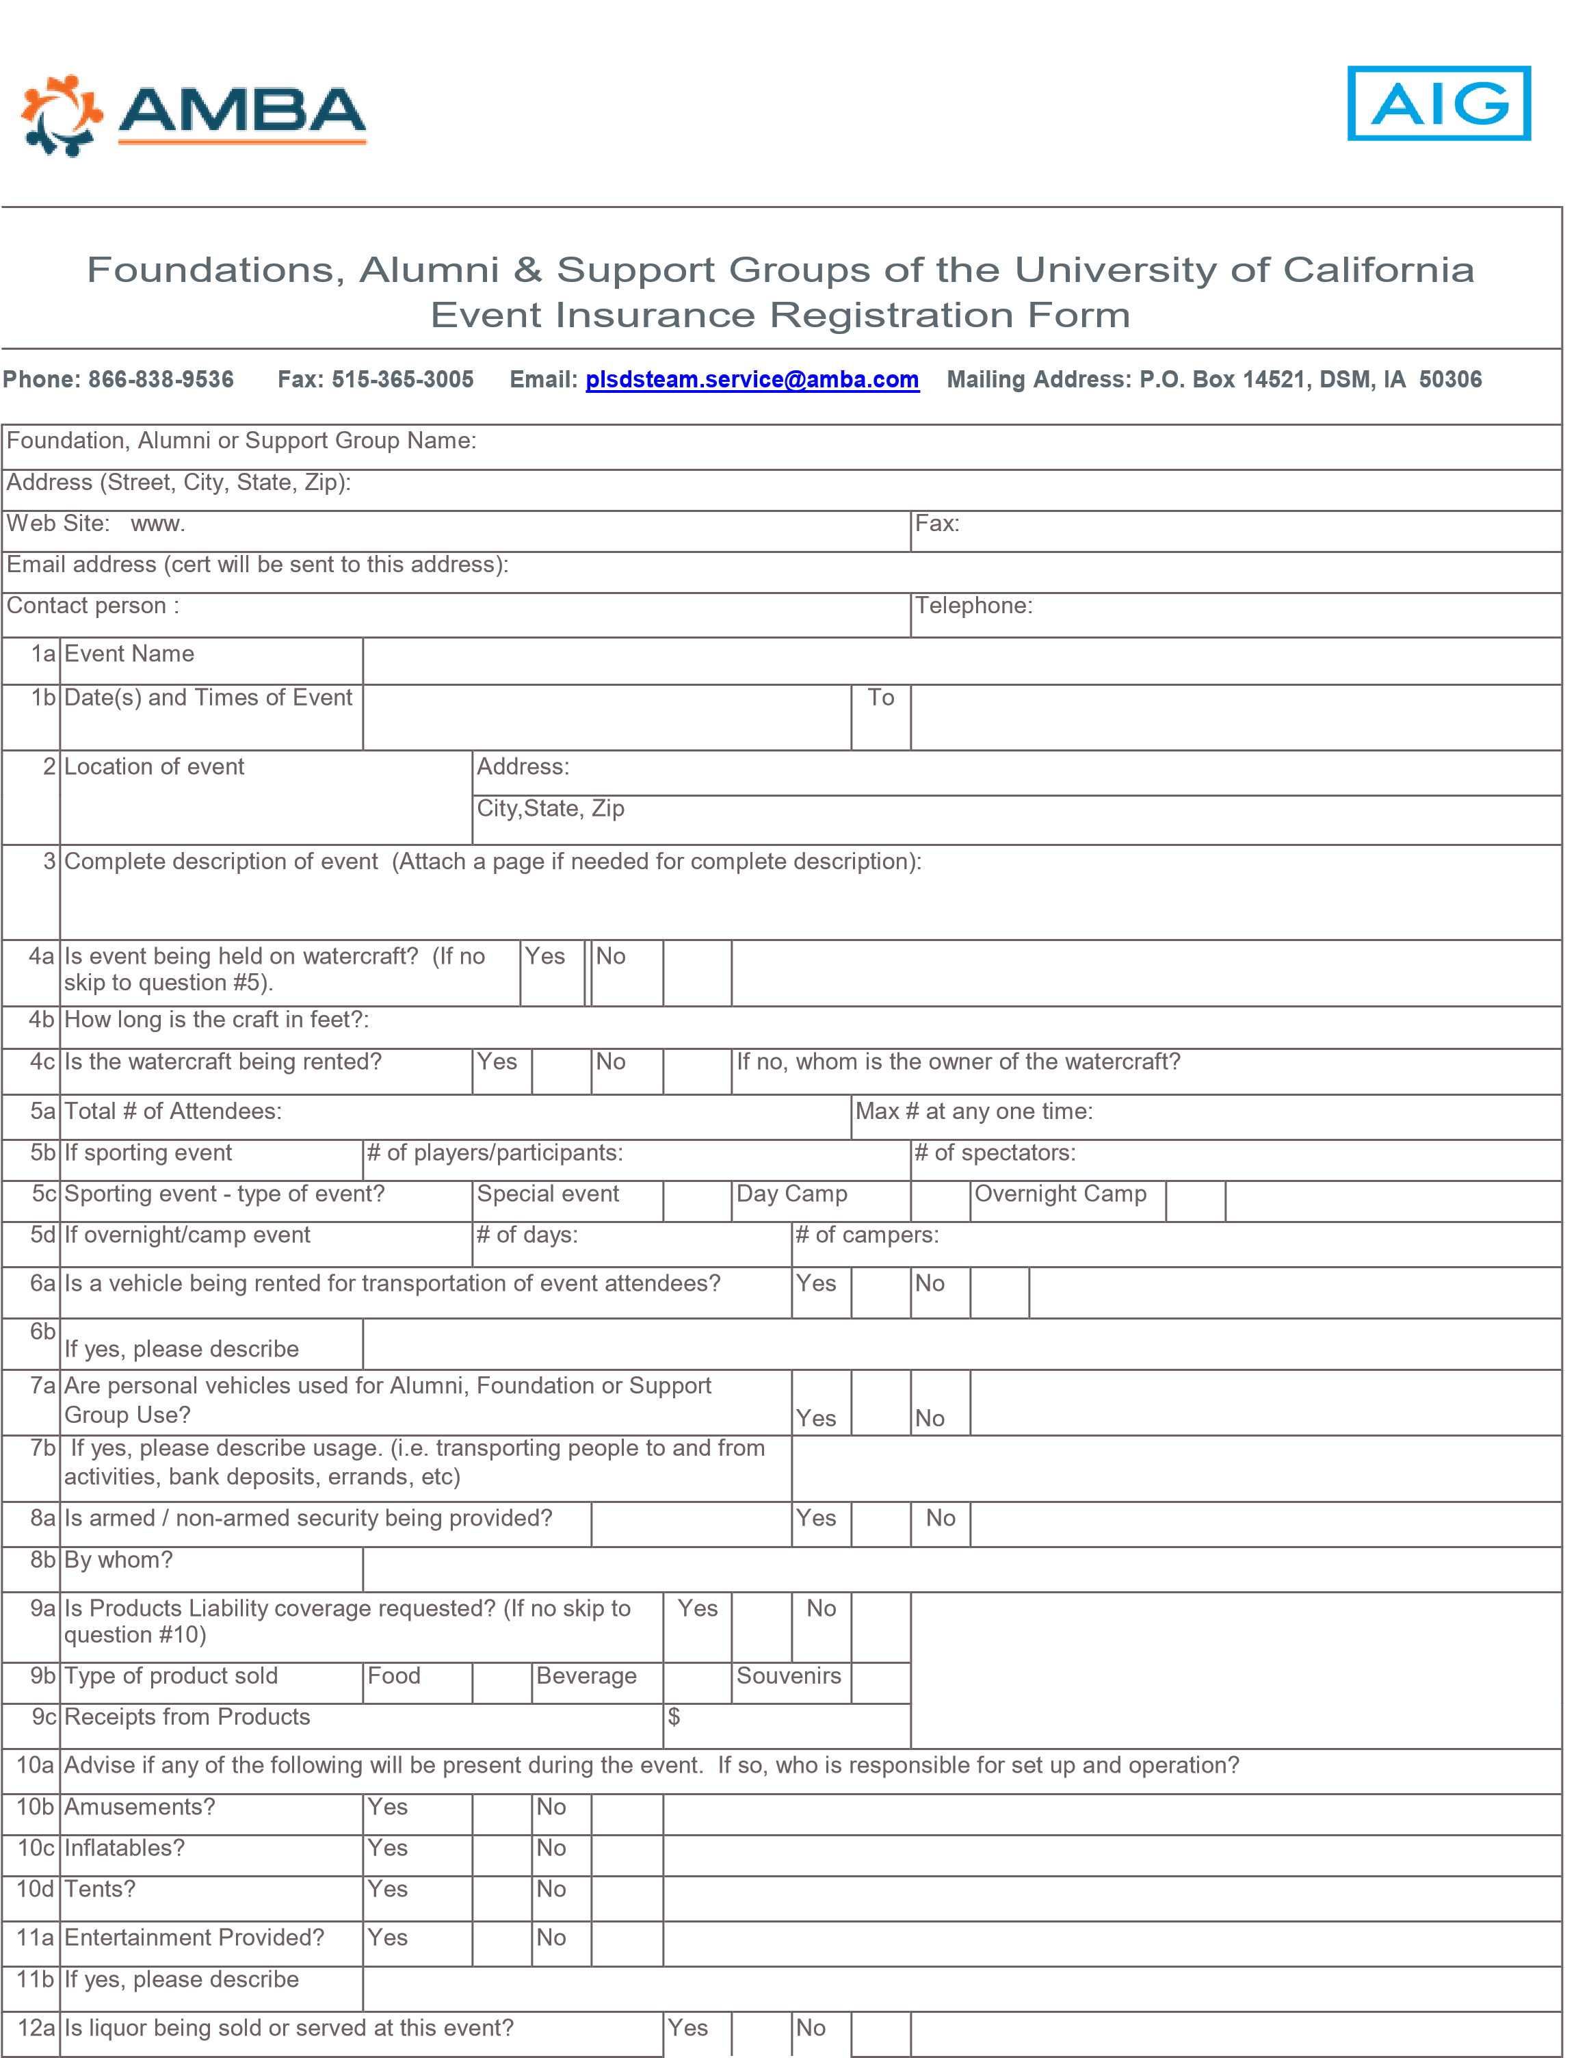
U of C FAS Event Application Page 1 of 3 06/01/2012
12b | If yes, who is furnishing/selling/serving the liquor?
13a | Did you hire an outside vendor? |  | Yes |  | No
13b | If yes, are you named on their policy as additional insured? Please give full details.
14a | Is your group providing valet parking for this event? |  | Yes |  | No
14b | If yes, are you hiring a valet parking service? |  | Yes |  | No
14c | If yes, are you named on their policy as additional insured? Please give full details.
Certificate Holder Detail #1 |  | Name
 |  | Address
 |  | City, State, Zip
Does the Certificate Holder want to be listed as additional insured? |  |  | Yes |  | No
Is the additional insured requiring any special verbiage or specific requirements? (Please provide specific verbiage or requirements if requested):
Certificate Holder Detail #2  (if needed) |  | Name
 |  | Address
 |  | City, State, Zip
Does the Certificate Holder want to be listed as additional insured? |  |  | Yes |  | No
Is the additional insured requiring any special verbiage or specific requirements? (Please provide specific verbiage or requirements if requested):

Fraud Notice

ANY PERSON WHO KNOWINGLY AND WITH INTENT TO DEFRAUD ANY INSURANCE COMPANY OR OTHER PERSON FILES AN APPLICATION FOR INSURANCE OR STATEMENT OF CLAIM CONTAINING ANY MATERIALLY FALSE INFORMATION, OR CONCEALS FOR THE PURPOSE OF MISLEADING, INFORMATION CONCERNING ANY FACT MATERIAL THERETO, COMMITS A FRAUDULENT INSURANCE ACT WHICH IS A CRIME AND MAY SUBJECT SUCH PERSON TO CRIMINAL AND CIVIL PENALTIES.

NOTICE TO NEW YORK APPLICANTS: ANY PERSON WHO KNOWINGLY AND WITH INTENT TO DEFRAUD ANY INSURANCE COMPANY OR OTHER PERSON FILES AN APPLICATION FOR INSURANCE OR STATEMENT OF CLAIM CONTAINING ANY MATERIALLY FALSE INFORMATION, OR CONCEALS FOR THE PURPOSE OF MISLEADING, INFORMATION CONCERNING ANY FACT MATERIAL THERETO, COMMITS A FRAUDULENT INSURANCE ACT, WHICH IS A CRIME AND SHALL ALSO BE SUBJECT TO A CIVIL PENALTY NOT TO EXCEED FIVE THOUSAND DOLLARS AND THE STATED VALUE OF THE CLAIM FOR EACH SUCH VIOLATION.

NOTICE TO KENTUCKY APPLICANTS: ANY PERSON WHO KNOWINGLY AND WITH INTENT TO DEFRAUD ANY INSURANCE COMPANY OR OTHER PERSON FILES AN APPLICATION FOR INSURANCE CONTAINING ANY FALSE INFORMATION, OR CONCEALS FOR THE PURPOSE OF MISLEADING, INFORMATION CONCERNING ANY FACT MATERIAL THERETO, COMMITS A FRAUDULENT INSURANCE ACT WHICH IS A CRIME.

NOTICE TO MINNESOTA AND OHIO APPLICANTS: ANY PERSON WHO, WITH INTENT TO DEFRAUD OR KNOWING THAT HE/SHE IS FACILITATING A FRAUD AGAINST AN INSURER, SUBMITS AN APPLICATION OR FILES A CLAIM CONTAINING A FALSE OR DECEPTIVE STATEMENT IS GUILTY OF INSURANCE FRAUD.

NOTICE TO NEBRASKA AND OKLAHOMA APPLICANTS: ANY PERSON WHO KNOWINGLY AND WITH INTENT TO INJURE, DEFRAUD OR DECEIVE ANY INSURER, MAKES ANY CLAIM FOR THE PROCEEDS OF AN INSURANCE POLICY CONTAINING ANY FALSE, INCOMPLETE OR MISLEADING INFORMATION IS GUILTY OF A FELONY.

NOTICE TO PENNSYLVANIA APPLICANTS: ANY PERSON WHO KNOWINGLY AND WITH INTENT TO DEFRAUD ANY INSURANCE COMPANY OR OTHER PERSON FILES AN APPLICATION FOR INSURANCE OR STATEMENT OF CLAIM CONTAINING ANY MATERIALLY FALSE INFORMATION OR CONCEALS FOR THE PURPOSE OF MISLEADING INFORMATION CONCERNING ANY FACT MATERIAL THERETO COMMITS A FRAUDULENT INSURANCE ACT WHICH IS A CRIME AND SUBJECTS SUCH PERSON TO CRIMINAL AND CIVIL PENALTIES.

U of C FAS Event Application Page 2 of 3 06/01/2012

NOTICE TO FLORIDA APPLICANTS: ANY PERSON WHO, KNOWINGLY AND WITH INTENT TO INJURE, DEFRAUD, OR DECEIVE ANY INSURER FILES A STATEMENT OF CLAIM OR AN APPLICATION CONTAINING ANY FALSE, INCOMPLETE OR MISLEADING INFORMATION IS GUILTY OF A FELONY OF THE THIRD DEGREE.

NOTICE TO NEW JERSEY APPLICANTS: ANY PERSON WHO INCLUDES ANY FALSE OR MISLEADING INFORMATION ON AN APPLICATION FOR AN INSURANCE POLICY IS SUBJECT TO CRIMINAL AND CIVIL PENALTIES.

NOTICE TO MAINE AND VIRGINIA APPLICANTS: IT IS A CRIME TO KNOWINGLY PROVIDE FALSE, INCOMPLETE OR MISLEADING INFORMATION TO AN INSURANCE COMPANY FOR THE PURPOSE OF DEFRAUDING THE COMPANY. PENALTIES INCLUDE IMPRISONMENT, FINES AND DENIAL OF INSURANCE BENEFITS.

NOTICE TO OREGON APPLICANTS: ANY PERSON WHO KNOWINGLY AND WITH INTENT TO DEFRAUD OR SOLICIT ANOTHER TO DEFRAUD AN INSURER: (1) BY SUBMITTING AN APPLICATION, OR (2) BY FILING A CLAIM CONTAINING A FALSE STATEMENT AS TO ANY MATERIAL FACT, MAY BE VIOLATING STATE LAW.

NOTICE TO DISTRICT OF COLUMBIA APPLICANTS: "WARNING: IT IS A CRIME TO PROVIDE FALSE OR MISLEADING INFORMATION TO AN INSURER FOR THE PURPOSE OF DEFRAUDING THE INSURER OR ANY OTHER PERSON. PENALTIES INCLUDE IMPRISONMENT AND/OR FINES. IN ADDITION, AN INSURER MAY DENY INSURANCE BENEFITS IF FALSE INFORMATION MATERIALLY RELATED TO A CLAIM WAS PROVIDED BY THE APPLICANT."

NOTICE TO NEW MEXICO APPLICANTS: "ANY PERSON WHO KNOWINGLY PRESENTS A FALSE OR FRAUDULENT CLAIM FOR PAYMENT OF A LOSS OR BENEFIT OR KNOWINGLY PRESENTS FALSE INFORMATION IN AN APPLICATION FOR INSURANCE IS GUILTY OF A CRIME AND MAY BE SUBJECT TO CIVIL FINES AND CRIMINAL PENALTIES."

NOTICE TO TENNESSEE APPLICANTS: "IT IS A CRIME TO KNOWINGLY PROVIDE FALSE, INCOMPLETE OR MISLEADING INFORMATION TO AN INSURANCE COMPANY FOR THE PURPOSE OF DEFRAUDING THE COMPANY. PENALTIES INCLUDE IMPRISONMENT, FINES AND DENIAL OF INSURANCE BENEFITS."

***Important***
In this transaction, AMBA is acting as the exclusive insurance agent and program manager for Philadelphia Insurance Company ("Insurer") for this type of coverage, and not as your insurance broker. Alternative insurance products may be available in the insurance market place. AMBA is only offering this selected insurer quote proposal. In addition, please note that we may utilize a third party wholesaler to gain access to insurers that we do not have direct access to in the insurance marketplace.
In accordance with industry custom, we are compensated through commissions that are calculated as a percentage of the insurance premiums charged by insurers. We may also receive additional monetary and nonmonetary compensation from insurers, or from other insurance intermediaries, which may be contingent upon volume, profitability, or other factors. This compensation may include payment from insurers for marketing related expenses or investments in technology. Our compensation may vary depending on the type of insurance purchased and the insurer selected. We will provide you additional information about our compensation and information about alternative quotes, upon your request.
You may obtain this information by referring to https://www.personal-plans.com/disclosure and enter in the security code o4875335 or call us at 1-888-206-5088 for specific details.
Signing this Application shall not constitute a Binder or obligate the Company to provide this insurance, but it is agreed this Application shall be the basis on which a policy may be issued. Coverage will become effective upon approval of this Application and acceptable payment of premium.
Insured Signature:
Date: Agent Signature:
Date:
Event Liability Application 2 06/01/2012
AR Ins. Lic. #100114462
CA Ins. Lic. #0196562
In CA d/b/a Association Member Benefits & Insurance Agency
U of C FAS Event Application Page 3 of 3 11/2011

